**PUBLICATION STANDARDS EINIACA15**

***Aportacións dos Novos Investigadores ao estudo da Arqueoloxía, Prehistoria e Historia Antiga***

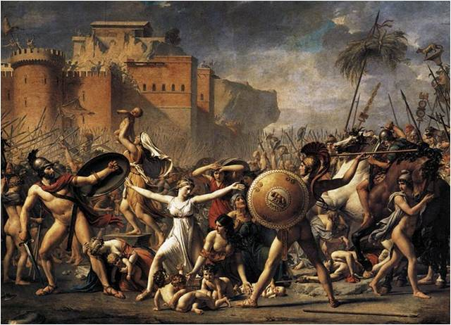

**1. Applicants**

The book *Aportacións dos Novos Investigadores ao estudo da Arqueoloxía, Prehistoria e Historia Antiga* is a work driven by the Organising Committee of the *I International Meeting of New Researchers of Archaeology and Sciences of Antiquity* (EINIACA), which intends to open new ways of communication among members of the university scientific community and to enrich the academic environment.

Therefore, this is a plural and scientific publication conducted by students and researchers who want to present their work within the context of Archaeology, Prehistory and Ancient History.   
 For this reason, only those submissions that were previously exposed in EINIACA will be admitted. The works have to be original. Those that have already been published or are in process of publication will be excluded. All the EINIACA participants who wish to publish their submissions must complete a commitment form of authorship, originality and transfer of rights for publication, and must sign and send a scanned copy (APPENDIX 1).

Similarly, the proposal submission deadline will be strictly observed, being the **October 1, 2015** the last day for submissions. All proposals must be sent to the email [*asoc.arq.ccaa@gmail.com*](mailto:asoc.arq.ccaa@gmail.com).

The submitted articles will be evaluated by peer review. The Scientific Committee shall be composed of scholars of each subject, from different universities, both Spanish and European, and they shall be fully responsible for such assessments.

The result will be communicated to the participants on January 8, 2016. In the case of the admitted submissions, the deadline to make the appropriate changes is February 24.

Prior to publication, a file with an imprint test will be sent to each author, so they will have the opportunity to make the last review. Only typographical or layout changes will be accepted. There will only be accepted significant changes in the text in exceptional cases. These changes will be made within deadlines; otherwise, the Organizing Committee may exclude those works that do not meet the deadlines.

**2. Languages**

The admitted languages for the publication of the submissions are Galician, Spanish, Portuguese, English, French and Italian.

**3. Form**

* Digital form (.doc or .odt).
* Size: A4.
* Page margins: superior and inferior of 3 cm and both sides of 2.5 cm.
* Font: Times New Roman, size 12 on the text; 11 on the textual quotes on the text; 10 on the footnotes and on the foot of pictures or graphics.
* Space between the lines: simple.
* Indentation: 1 cm in the first line of each paragraph.
* Text: one column, justifying the lines.
* Page numbering: consecutive Arabic numerals, centred at the end of page.
* Authors are requested not **to** use the “automatic formatting” or “styles” in the text.

**4. Extent**

In the case of the poster proposals, there will be **6 pages** in total (including bibliography, footnotes and pictures). The submissions will have an extension of **18 pages** in total (including bibliography, footnotes and pictures).

**5. Presentation proposal** (APPENDIX 2)

Must be listed in the first page, in the following order:

* The **title** of the proposal in the language of submission: in capital letters, 14 size, bold and centred.
* The **subtitle** (if any) in the language of submission: in capital letters, 12 size, bold and centred.
* The **title of the English proposal**: in capital letters, 14 size, bold and centred.
* The **subtitle of the English proposal**: in capital letters, 12 size, bold and centred.
* The **author/s name/s**: in capital letters, 12 size and lined up to the right; in the next line, also right-lined up, it must appear the e-mail, 11 size in cursive; the institutional filiation must be indicated in other line, if any, 11size in cursive.
* The **keywords** must appear in the submission’s language: 12 size, maximum of 6 words.
* The **abstract** of the proposal must appear in the submission’s language: between 80-160 words, 12 size.
* The **English keywords**: 12 size, maximum of 6 words.
* The **English abstract**: between 80-160 words, 12 size.

**6. Text**

* **Title**: in small letter, 12 size, bold and with consecutive Arabic numerals. After the title, it must leave a blank space before the first paragraph; leave no blank space if any following subtitle.
* **Subtitle**: in small letter, 12 size with consecutive Arabic numerals. After the title, leave a blank space before the first paragraph.
* Between each title and subtitle there must be a blank space, but not blank space between the paragraphs.
* The **graphics** (in JPEG, PNG or TIFF format) that the author considers necessary should be included, indicating on the foot if it’s a figure (“Fig.”) or it’s a table (“Table”), and adding a brief explanation in size 10 in cursive. All the tables and figures must make reference to the text and must be presented in consecutive Arabic numerals.

Examples:

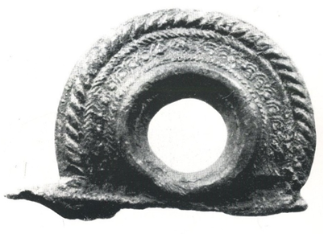

*Fig. 1 Sítula’s handle of Castrovite (A Estrada, Pontevedra) (Carballo 1986: Lam. XXX).*

*Table 1. Figure representing the percentage os chosen materials.*

**7. Quotations**

When an author’s or a quotation’s reference is included, its origin must be indicated in the text, not in a footnote. Additionally, any term in a different language must be written in cursive, including the classic languages.

* **Modern authors:**
* (Rodríguez Álvarez 2009: 273-274).
* (Costas Goberna *et al.* 2003; Rodríguez Álvarez 2009).
* (Belén Deamos; Chapa Brunet 1997).
* **Classical authors:**
* **Latin**: according to the *Oxford Latin Dictionary*. (Ex. CAES. *Ciu.* 1. 7. 5).
* **Greek**: according to the Lidl&Scott-Jones (Ex. APP. *Mith.* 25).
* **Other languages**: the Organising Committee must be consulted.
* **Epigraphic documents:** according to L’Année Epigraphique. Ex.: (CIL. XIII 8824).
* **Numismatic documents**: according to the M. H. Crawford *Roman Republic Coinage* (RRC) for the republican period and according to the H. Mattingly *et al.* *The Roman Imperial Coinage* (RIC) for the imperial period. Example: (RRC 475/1a).

**7. 1. Direct quotations**

Direct quotations must be included in English quotations marks and its origin must be referred. If the quote does not exceed three lines, it will be assimilated in the text, in 12 size; but, if the quote exceeds three lines, it must appear in a separate paragraph, in English quotations marks, 11 size and with an indentation of 2 cm both sides. There will not be any space between the text paragraph and the quote paragraph.

**7. 2. Ancient sources quotations**

They must be included in Italics, in Unicode font for Greek; for other languages, it is requested to send the font by e-mail to the Organising Committee. If the quote does not exceed three lines, it will be assimilated in the text, in size 12; but, if the quote exceeds three lines, it must appear in a separate paragraph, in English quotations marks, size 11 and with an indentation of 2 cm both sides. There will be not any space between the text paragraph and the quote paragraph.

**8. Footnotes**

They will appear in size 10, with consecutive Arabic numerals, without spaces between the notes. To restrict the use of footnotes, it is requested to use those that make an easier comprehension of the text.

**9. Bibliography**

Only the mentioned sources will be included, both the modern and the classical sources, alphabetically ordered, without blank spaces between titles, size 11 and with single space between lines.

**9. 1. Modern authors**

Their names should be indicated in capital letters, followed by the initial of the name, date of publication, title, publisher and place of publication. Examples:

* A complete work:
* One author:

VERVAET, F. J. (2014): *The high command in the Roman Republic: the principle of the* summum imperium auspiciumque *from 509 to 19 BCE*, Franz Steiner, Stuttgart.

* Coordinators and directors:

GÓMEZ PANTOJA, J. (coord.) (2005): *Historia Antigua (Grecia y Roma)*, Ariel, Barcelona.

CROOK, J; LINTOTT, A.; RAWSON, E. (eds.) (1994) *Cambridge Ancient History. IX, The last age of the Roman Republic*, CUP, Cambridge.

* Several authors:

COSTAS GOBERNA, F. J.; PEÑA SANTOS, A. de la (2011): *Los barcos de los petroglifos de Oia. Embarcaciones en la prehistoria reciente de Galicia*, Autoridad Portuaria de Vigo, Vigo.

* Several works of the same author:

BRUNT, P. A.:

* + - (1971): *Italian manpower: 225 B. C.-A. D. 14*, Clarendon Press, Oxford.
    - (1986): “Cicero´s officium in the Civil War”, *JRS* 76, 12-32.
* Chapter of a work:

LÓPEZ BARJA DE QUIROGA, P. (2008): “La concepción política del territorio en la Roma republicana”, en MANGAS, J.; NOVILLO M. A. (eds.): *El territorio de las ciudades romanas,* Sísifo, Madrid, 27-38. *El territorio de las ciudades romanas*, J. MANGAS y M. A. NOVILLO (eds.), Sísifo, Madrid, 27-38.

* Article review:

CHRISSANTOS, S. G. (2001): “Caesar and the Mutiny of 47 B. C.”, *JRS* vol.91, 63-75.

* Digital works:

AGUILERA DURÁN, T. (2012): “Una visión historiográfica alternativa: la deconstrucción del estereotipo del bárbaro prerromano”, *Antesteria. Debates de Historia Antigua* nº1. Retrieved <http://www.antesteria.es/n1-2012.html> from 24/06/15.

**9. 2. Classical authors**

The name must be indicated in capital letters followed by the work’s title in italics, the editorial, translation, date and place of edition. Examples:

APIANO, *Historia Romana II. Guerras civiles*, Gredos (Trad. de Antonio Sancho), 1995, Madrid.

CICERÓN, MARCO TULIO:

* *Cartas a Ático*, Gredos (Trad. de Miguel Rodríguez-Pantoja), 1996, Madrid.
* *Cartas a los familiares*, Gredos (Trad. de José A. Beltrán), 2008, Madrid.

**9. 3. Digital sources**

It must be indicated the web page with the link and the last date of retrieval. Example:

<http://mercure.fltr.ucl.ac.be/Hodoi/concordances/appien_mithridate/lecture/default.htm> (Retrieved: 24/06/15).

**AUTHORISATION FOR THE PUBLICATION OF EINIACA PAPERS**

**(APPENDIX 1)**

Mr./Mrs.____________________________________________________________________________, ID: ______________________________,

**THE AUTHOR DECLARES THAT:**

* The paper is an original authored work.
* The paper has not been published nor is in publishing process.
* The author signs over the rights of the publication and diffusion of the paper to the *Asociación Cultural de Arqueoloxía e Ciencias da Antigüidade* (ARCIAN) and to the *I International Meeting of Young Researchers in Archaeology and Ancient Sciences* (EINIACA).

**AND REQUESTS:**

The publication of his/her research presented at the *I International Meeting of Young Researchers in Archaeology and Ancient Sciences* (EINIACA), that took place the 10th, 11th and 12th of June 2015 in Santiago de Compostela, as an article in the book *Aportacións dos Novos Investigadores ao estudo da Arqueoloxía, Prehistoria e Historia Antiga.*

And for the record, the author signs the current authorisation, **i**n __________________, _______ of ___________, 2015.

SIGNATURE OF THE AUTHOR

_______________________________

APPENDIX 2

**TITLE OF PAPER OR POSTER**

[Times New Roman 14 bold]

**SUBTITLE**

[Times New Roman 12 bold]

**TITLE OF PAPER OR POSTER (ENGLISH)**

[Times New Roman 14 bold]

**SUBTITLE**

[Times New Roman bold]

Name SURNAME

[Times New Roman 12]

*E-mail*

[Times New Roman 11, cursive]

*Filiation*

[Times New Roman 11, cursive]

**KEYWORDS** [Times New Roman 12, bold]**:** maximum 6 words [Times New Roman 12]

**ABSTRACT** [Times New Roman 12, bold]**:** 80-160 words [Times New Roman 12]

**KEYWORDS (ENGLISH)** [Times New Roman 12, bold]**:** maximum 6 words [Times New Roman 12]

**ABSTRACT (ENGLISH)** [Times New Roman 12, bold]**:** 80-160 words [Times New Roman 12]

[two blank spaces]

**1. Title 1** [Times New Roman 12, bold]

Text

[one blank space]

**2. Title 2** [Times New Roman 12, bold]

2. 1. Subtitle 1 [Times New Roman 12]

Text

[one blank space]

2. 2. Subtitle 2 [Times New Roman 12]

Text

[one blank space]

**Bibliography** [Times New Roman 12, bold]

* Modern authors [Times New Roman 11,bold]

[authors and Works in Times New Roman 11]

* Ancient sources [Times New Roman 11, bold]

[authors and Works in Times New Roman 11]

* Digital sources [Times New Roman 11, bold]

[Times New Roman 11]